IT’S BACK!
GCBA Winter Bowling Rendezvous

GET YOUR TEAMS TOGETHER!
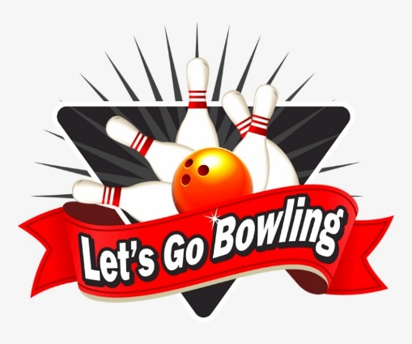

NEW LOCATION:

WICKLIFFE LANES
30315 EUCLID AVENUE
WICKLIFFE, OHIO

ONE SHIFT ONLY – 2:00 – 5:30 P.M.
TWO DAYS OF BOWLING

SUNDAY, JANUARY 9, 2022

SUNDAY, JANUARY 23, 2022

FIRST 40 TEAMS TO REGISTER

BANQUET & AWARDS
FEBRRUARY 12, 2022

NORMANDY PARTY CENTER
30310 PALISADES PARKWAY
WICKLIFFE, OHIO

SEE FLYER FOR REGISTRATION DETAILS

