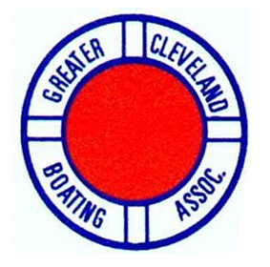
What’s in it for you?
The Greater Cleveland Boating Association is a recreational boater advocacy organization that serves boaters from Ashtabula to Sandusky. Our goal is to keep you informed on boater education opportunities, safety, political action impacting the Great Lakes, and local, state and federal programs that affect our harbors, parks and shorelines.
Come join us at our monthly meetings. We have lined up some great speakers to share their knowledge and experience with us. Please remember that our meetings are open to every GCBA club and it’s members – not just the delegates. These meetings are held in-person as well as online for your convenience. The speaker presentations will be very interactive, with plenty of time available for Q&A.

February 15, 2022. ODNR Office, 1150 East 49th St., Cleveland OH 44114
Guest Speaker: Ray Treudler, North Coast Prop Tech, Inc. Huron, OH https://www.northcoastproptech.com
Ray will be speaking to us about propellers, shafts, and dripless packings. He will cover his unique patented repair methods, general upkeep, and guidelines to determine if your boat is propped adequately, or in need of some fine tuning. 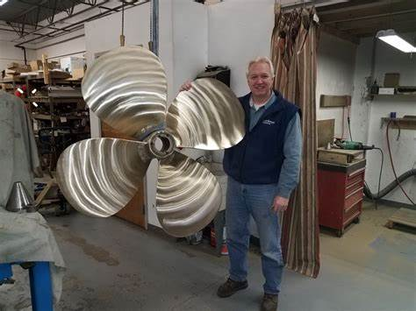 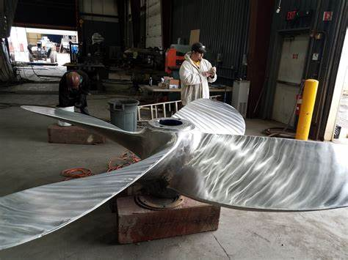
March 15, 2022 Lakeside Yacht Club, 4851 N. Marginal Rd., Cleveland, OH 44114
Guest Speaker: U.S. Customs and Border Protection, Cleveland office
A local Customs and Border Protection officer will be speaking to us about the proper reporting requirements for pleasure craft operating on the Great Lakes. They will also touch on the most current updates regarding travel restrictions due to the Coronavirus.

April 12, 2022 Forest City Yacht Club 5301 N. Marginal Rd., Cleveland, OH 44114
Guest Speaker: Brian Cossu from Marine Detail Supply Company Port Clinton, OH
https://marinedetailsupply.com
Brian will be speaking with us about the most advanced products and application methods on the market today to make our boats shine! Topics will include compounding, wet sanding, machine basics, polymer sealants, ceramic coatings, and more.
GCBA General Meetings, Go-To-Meeting links:
Tue, Feb 15, 2022 7:30 PM - 10:30 PM (EST)
Please join my meeting from your computer, tablet or smartphone.
https://global.gotomeeting.com/join/893866525

Tue, Mar 15, 2022 7:30 PM - 10:30 PM (EDT)
Please join my meeting from your computer, tablet or smartphone.
https://global.gotomeeting.com/join/415851805

