GCBA JOE CHASE MEMORIAL FUND RAISER
FOR SAFETY & EDUCATION
When : check in starts Fri July 21 with Events all day Saturday July 22,2023

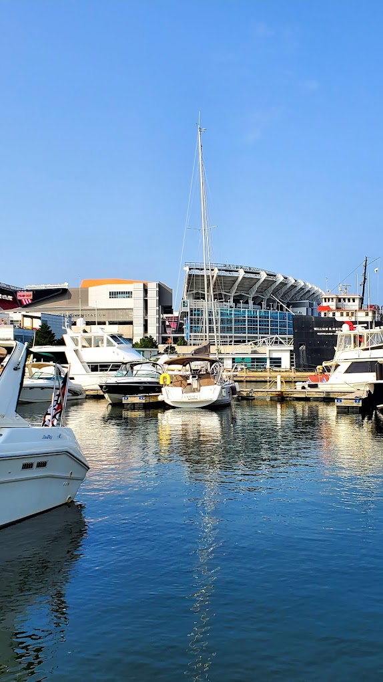
Saturday Events to include 50/50 raffle all day drawing, at 7pm
Lunch Burgers and dogs 1pm to 3pm $10 donation
Chinese Raffle baskets
Paddle raft races with prizes
Discount tickets for some surrounding Attractions
Special dock pricing
And grand finale for the day PARADE OF LIGHTS down the Cuyahoga River at approximately 21:30 Hr with best decorated boat prizes by Oasis Marina
For more information, please contact Capt. Don Young Commander GCBA
And if possible to let’s know you are coming to have idea of how many people

