GCBA Annual Memorial Day service
Monday May 29th @ 10:00 am
COME HELP US SUPPORT OUR PAST MEMBERS AND FALLEN MILIATARY
WHO HAVE PASSED ON AND SUPPORT THE FAMILIES LEFT BEHIND
IN THIS SPECIAL SERVICE

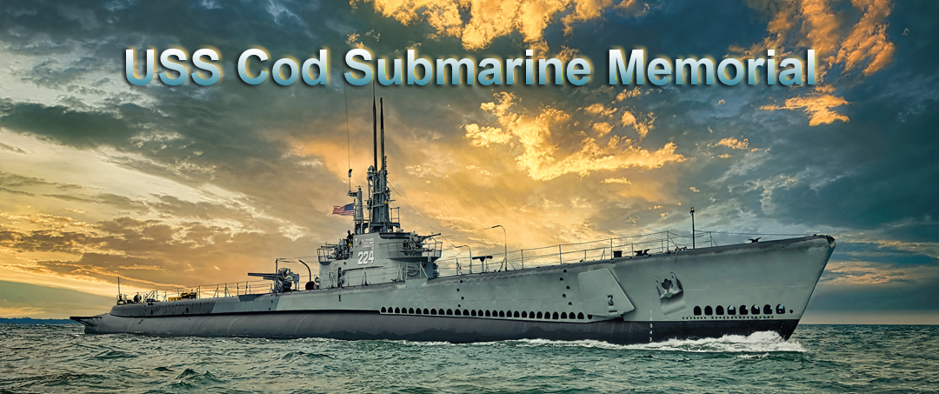
Line up for the parade portion will begin at Burke Lake Airport at approximately 9:30am and the parade will go to the USS Cod
Anyone wishing to have a family member honored please send a notice of name, the club belong to and or branch of office and they will be added to the list of names to Nick Hostottle Flag Lieutenant @ nickhostottle@yahoo.com
Also, any deceased members that you have before 3-1-23 will be added to the who’s who book
Thank you and we look forward to seeing many of you on May 29th, 2023

